**11-etl-Team08:**

Mark Alcocer

John Boer

Kenjicai Brock Dong

**Extraction**

We used 2 datasets from Kaggle and the Yahoo Finance API. Our data was based on video game releases and the parent company’s stock from 2017-2016. The sources for our dataset are as follows

* Video Game Sales .csv from Kaggle.
* Video Game Metacritic Scores .json from Kaggle.
* Company Stock Data from Yahoo API.

**Transformation**

.csv

1. Dropped the unnecessary columns





2. Filtered for desired date range





3. New column for platform company

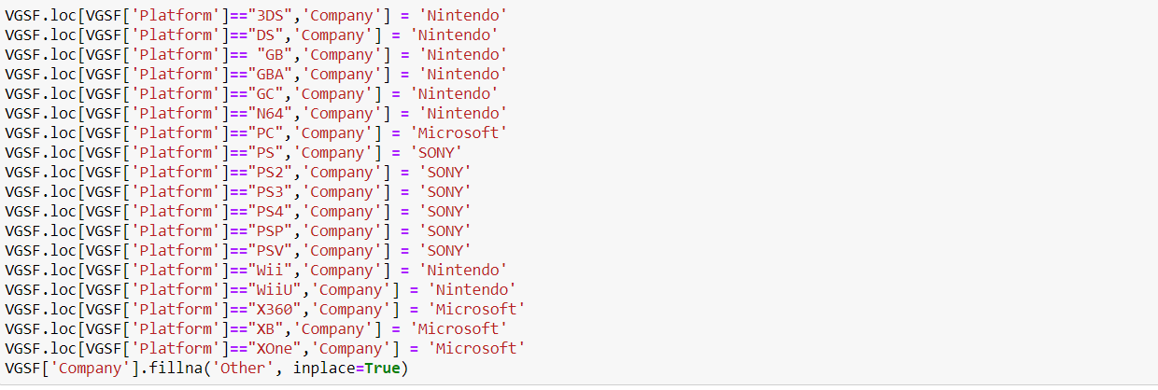

.json

1. Dropped unnecessary columns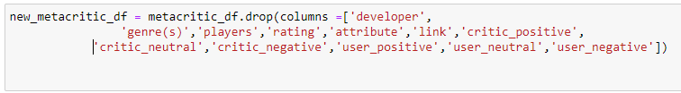
2. Renamed columns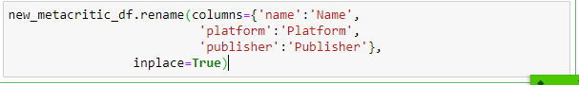
3. Created new column for platform company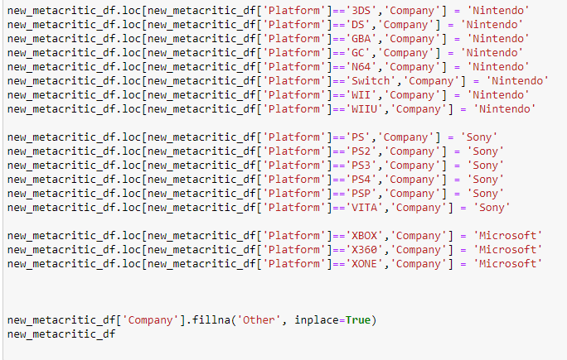
4. Changed MM/DD/YYYY to only YYYY format



1. Filtered for desired date range



Yahoo Finance API

1. Collected financial information for Nintendo, Microsoft, and Sony.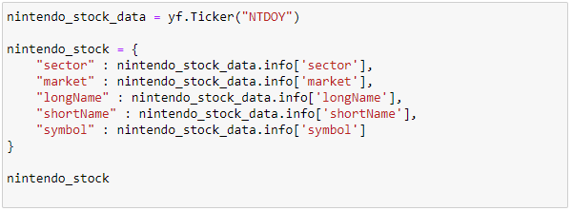

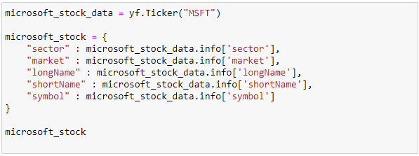

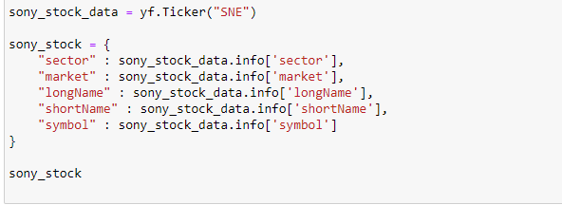

1. Filtered for desired date range







1. Transformation

**Load**

The last step was to transfer our final output into the Postgres database. We created a database called *videogames* and 6 tables to load our data.

Inserting stock data to the database:

Inserting the video games data to the database:

Summary

We used these datasets so we could identify the game companies of game platform, the Metacritic scores of the games, the North American sales of the games, and the stock prices of the companies. The final output will help us to recognize which the following:

* How Metacritic score affect sales?
* How sales affect stock over time?
* How Metacritic score affect stock over time?
* How does different platform affect the stock over time?

The indices can be used to identify which factor have a bigger impact on the company stock price. If the videogame results can determine the stock price of the big three game company: Nintendo, Sony and Microsoft.